Ideas for acorns- Antarctic. Weeks beginning 18th and 25th January
Please pick and choose as many of the following as you would like. If you would like to show me what you are up to at home, please either upload photos to tapestry or send via email. I look forward to hearing from you all.
Story focus- Lost and Found by Oliver Jeffers
Communication and language  Speaking  I listen to stories with increasing attention and recall.  Understanding  I show understanding of prepositions such as ‘under’, ‘on top’, ‘behind’ by carrying out an action or selecting correct picture. | Physical development  Moving and handling  I can hold a pencil between thumb and two fingers, no longer using whole-hand grasp.  (Funky fingers activities help to develop finger strength leading to a good pencil grip) | Literacy  Reading  I describe main story settings, events and principal characters.  I am beginning to be aware of the way stories are structured.  I suggest how the story might end. | Literacy  Writing  I sometimes give meaning to marks as I draw and paint | Maths  Number  I show an interest in number problems.  I separate a group of three or four objects in different ways,
Read/ watch Lost and Found Oliver Jeffers- https://www.youtube.com/watch?v=cRAAQ8EWzig&t=31s  What would tell the penguin- what is your favourite story?  What would you pack in the suitcase?  Find a penguin or a toy boy- can you put them on top of something, beside something, behind etc. get your grown up to take a photo of the ones you could do. | Funky fingers-  - Use a spoon to spoon rice into different size containers  - Make some playdough – make some penguins of different sizes  - Balance some cubes. How big can you get your tower?  - Practise holding a pen or pencil with a tripod grip. Can you make some marks?  - Cutting bin. Fill a tub with anything that can be cut. Different textures are good. Remember keep your thumb on top when using your scissors. | After reading/ watching Lost and found- What part of the story did you like the best? How did it make you feel? Can you draw that part?  Get your grown up to draw a suitcase or use a real one- what would you put in? if you put in a woolly hat which sounds would match the object? Can you find that sound?  Sound bingo and sound puzzles  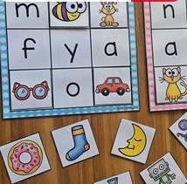 | Using zig zag lines straight lines and curvy lines try and write over the lines with your favourite pens. Don’t stop keep it going all the way to the end.  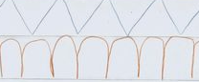  Have a go at writing your name in the sand, flour, rice  Spread out some tinfoil- use marker pens, paint and mark make on the foil. | Play games that involve using a dice and counting out the squares  Play dominoes to match numbers or pictures  Make playdough fish to feed the penguins  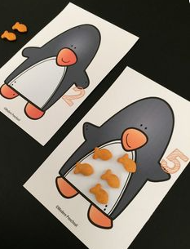  Playing with numbers 1-10. Can you order them, find the one that’s missing if your grown up takes it away, count up count down?
Maths  Shape space and measure  I use positional language.  I show interest in shape by sustained construction activity or by talking about shapes or arrangements | Expressive arts  Exploring and using materials  I sing a few familiar songs.  I am beginning to move rhythmically.  I imitate movement in response to music.  I tap out simple repeated rhythms.  Being imaginative  I am developing preferences for forms of expression.  I use movement to express feelings. | Understanding the world  The world  I talk about why things happen and how things work. | Understanding the world  Technology  I show an interest in technological toys with knobs or pulleys, or real objects such as cameras or mobile phones. | Physical development  Moving and handling  I hold pencil between thumb and two fingers, no longer using whole-hand grasp.  I hold pencil near point between first two fingers and thumb and use it with good control.
(Activities to build confidence in shape recognition)  make shape penguin 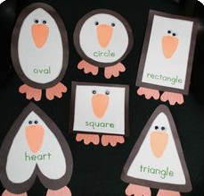  Shape printing- use blocks, potatoes, bricks etc  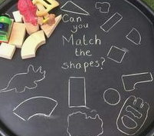  Shape match the silhouettes  Draw around shape shadows  What shapes can you find in your house? | 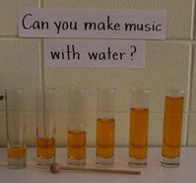try making your own musical instruments. You could make a water xylophone or a rice shaker for example.  Can you play your instrument along to your favourite song.  Make up a dance for your favourite song and sing along  Learn the penguin song and dance- https://www.youtube.com/watch?v=uf0uKmKwnKs | The boy took the penguin back to the south pole. Make some ice cubes- what did you have to do? How can you make the ice melt? What happens when it melts?  How do you think the boy kept warm for the journey- ask your grown up to get a pile of clothes. Sort them into things that keep you warm and things that keep you cool.  Cook and bake- how do ingredients change? Maybe make penguin biscuits | Do you have a cd player? How do you make it work?  Do you have a camera? How do you make that work? | 2 Ingredient Play Dough Recipe  - 1/2 cup hair conditioner  - 1 cup cornstarch (you will need more to get the right consistency, but this is a good starting point).  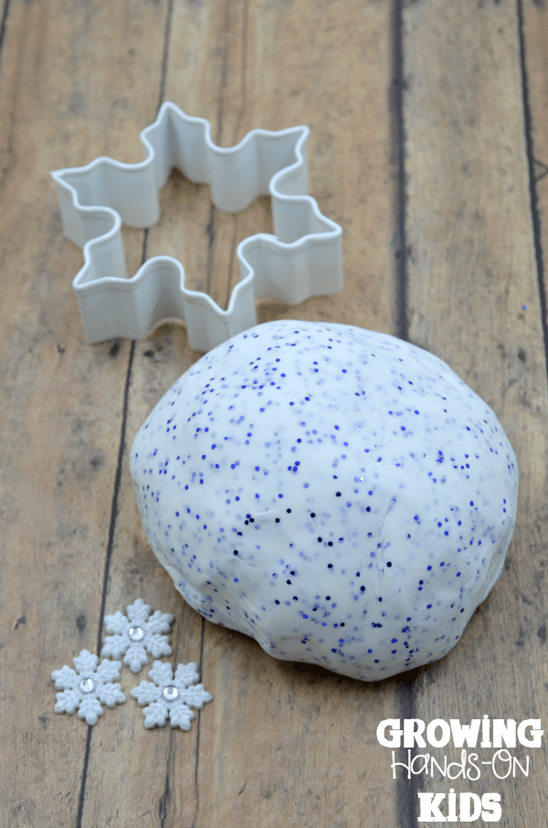  Use the playdough to practise a pinching movement with your thumb and finger. Pinch a snowflake shape. Pinch an icicle etc  Colouring- colour a picture  Run, jump, climb, swing, play football- all the things you usually do :0)

Phonics Phase 1 and 2
- Target sounds- make a sound target can be letters or animals that make sounds. Make the noise/ sound and shoot with a nerf gun, water pistol, spray bottle, swat with a fly swat etc
- Sing! Nursery rhymes, pop songs- if you have a drum, tambourine etc try and follow the beat.
- Rhyme time- start with a word dog, cat etc how many rhymes can you think of?
- Watch alphablocks
- Go for a listening walk- get your grown up to write down what you can hear.
- Can you copy a sound? Use either instruments or claps, stamping etc. adult does the first sequence child tries to copy. Switch it – child makes the pattern adult copies.
- Make up rhyming names for some of your toys eg fizzy whizzy lizzy
- I spy

Helpful websites:
https://www.oxfordowl.co.uk/
https://app.gonoodle.com/
https://www.storybots.com/
https://www.teachyourmonstertoread.com/
vooks.com

